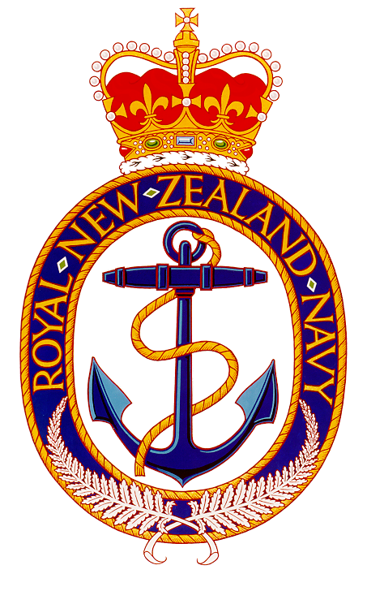 | Navy Museum Historical Research

Subject: Fuel Tanks at Tuff Crater

Background
The first fuel tanks were constructed on the base in 1922 and 1924 due to the arrival of the oil fired cruisers HMS Dunedin and Diomede which were the first oil-fuelled vessels to serve in New Zealand. They were both 6,000 tons in capacity. A third tank that could hold 12,000 tons was completed in 1939 and demolished in 1948. In 1944 there were four underground fuel tanks built close by the tunnel to Ngataringa Bay each capable of holding 6000 tons of fuel oil. These were built on plans supplied by the Admiralty in a horseshoe shape, 120m long x 9m wide x 7.8m high. The work was completed in 1946 and remained in use until the 1990s when a direct connection with a commercial bulk fuel installation was set up on the other side of the harbour. Our records indicate that in 1965 Fuel Tanks 1 and 2 were demolished and a combined marine shop built on the site. These tanks stored a product known as FFO or Fleet Fuel Oil. This fuel oil was heavy and viscous oil, and did not burn until heated to around 1000° Fahrenheit, the temperature inside a ship’s boiler. If spilled, it could be cleaned up with relative ease.

The American involvement began in 1942 following the Japanese attacks in December 1941. By March of 1942, the Allied navies had been driven from South East Asia and plans were being made to launch an offensive against Japanese held positions. The Battle of the Coral Sea in May of 1942 stabilised the Allied position and checked the Japanese advance. On 21 May American Vice-Admiral Robert L. Ghormley arrived in Auckland. On 19 June he assumed command of South Pacific Area and South Pacific Force with his headquarters at Auckland. This began the arrival of USN ships into Auckland. At the end of June it was decided to launch an offensive against the Japanese in the Solomons targeting the island of Guadalcanal. American warships began to come and go regularly as part of the operations carried on throughout the Pacific. One 18 July Amphibious Force, South Pacific Area was established under the command of Rear Admiral Kelly Turner at Auckland. This covered the US Marines tasked with the Guadalcanal landings.

The landings were scheduled for 7 August and on 1 August Vice Admiral Ghormley, who had departed Auckland with his staff, established his headquarters aboard the auxiliary USS Argonne at Noumea, at the time a major forward base for the operation. By the end of the year the Americans were making progress against the Japanese forces ashore and at sea. By 9 February 1943 Guadalcanal was secured and Tulagi became a major naval base for the Solomons and supported the USN as it proceeded north-westwards along the island chain. The use of Auckland as a base quickly ended as Tulagi was accessible to USN vessels for refuelling. Although the Untied States forces had a presence in New Zealand until the end of the war, their major involvement was over by the end of 1942.

Use of Tuff Crater

In late 1942 the RNZN had planned to build two 12,000 ton capacity tanks at Shoal Bay – Tuff Crater. Due to the difficulties of wartime construction the plan was dropped in February 1943 and the underground tanks were built at the navy base into the cliffs referred to earlier.

The establishment of Auckland as a depot and distributing centre for the initial stages of the Pacific Campaign by the US Navy meant that bulk storage for fuel oil was required. The quantity considered in mid 1942 was 20,000,000 gallons [75,708,000 litres]. Three sites were proposed and the site at Northcote [Tuff Crater] was selected. It would be known as Fuel Tank Farm, Northcote. Plans were approved by the naval staff in Washington.

The plan provided for 50 tanks each holding 350,000 gallons [1,324,890 litres] spaced about 300ft [91m] apart set into the site on a irregular line following the foreshore around the crater and the cliffs facing Bayswater. The tanks were 55ft [17m] in diameter and would need some excavation so they could stand on solid ground. All materials for the project including the pumps, piping and the prefabricated tanks would be supplied by the Americans to the Public Works Department who would carry out the construction. Each tank would be connected by a 12-inch [30.48cm] leader line and separate pumps would connect each tank. A six-inch [15.24cm] line provided a foamite fire fighting service to the tank farm. A service road was planned to wind around each tank site and join up with the proposed control offices.

Refuelling would not take place off the tank farm as it was too shallow for a warship to operate. Twin six-inch [15.24cm] pipes were planned to be laid from the tank farm to the fuelling point at Stanley Bay Wharf. These pipes crossed the two bays and the Bayswater Peninsula a total length of two miles [3km]. Due to the length of pipe and the flat grade booster pumps were required and these were to be installed on the peninsula so that the required rate of refuelling for a warship could be obtained. That is because fuel oil needs a constant pressure to fill the tanks aboard ship. At Stanley Bay, mooring facilities would be built for tankers to discharge to the tank farm and to refuel warships. The existing jetty was to be extensively added to. A key mooring was built to give warships 30ft [9m] of water at low tide. The wharf would be connected to the control office at the tank farm by telephone.

The Public Works Department began work on the project but it was cancelled by the Americans after nine months’ work. During the construction, 200,000 cubic yards excavated to create 25 tank sites and 25 60ft [18m] concrete footings were laid. The tanks were constructed using prefabricated parts and were bolted together. Six tanks were assembled and were in the process of being tested for storage. At Bayswater a pumping station was partially erected. All unused materials were collected and loaded aboard a transport ship at Auckland for reshipment overseas. The costs to the government at the time of cancellation came to £138,797.

