2018 SOUTH ISLAND GATHERING

26-28 October 2018

Tautuku Outdoor Education Centre
Tautuku, RD 2 Owaka 9586

Registration Form

Please complete and send form to dunedin.branch@forestandbird.org.nz or
alternatively post to PO Box 5793, Moray Place, Dunedin 9058

Registration will be confirmed upon receipt of payment
Registrations close on 10 October 2018

Personal Information
Last Name: | First Name: |  | Title:
Street Address/PO Box:

Suburb: |  | City & Postcode:
Phone Number(s): |  | Email Address:
Branch:

Special Dietary Requirements:

Other Requirements:

Registration details and fees
Service | Cost per person | Number of people | Total in $
Registration fee | $55
Accommodation
Tautuku Outdoor Education Centre – Friday and Saturday night – 2 nights
Please tick preferred room type (for more details, see below) – first come, first served:
Dorm room | $50
☐ Double room (very limited numbers)  ☐ Twin room (very limited numbers)  ☐ Triple room (very limited numbers) | $70
Single room (very limited numbers) | $80
If you wish to organize your own accommodation, please see our suggestions at the end of this form
Meals (on-site catering)
Friday dinner | $30
Saturday breakfast | $8
Saturday lunch | $20
Saturday dinner | $30
Sunday breakfast | $8
Sunday lunch | $20
Transport to/from event site
By bus from Dunedin Airport  On Friday at 4:00pm | $27
By bus from Dunedin Airport  On Friday at 7:30pm | $27

Service | Cost per person | Number of people | Total in $
By bus to Dunedin Airport  On Sunday at 12:30pm | $27
By bus to Dunedin Airport  On Sunday at 3:00pm | $27
Total to pay

Payment Method
☐ | By direct deposit / Internet banking:  Bank Account Name: Dunedin Branch Forest and Bird  Bank: Kiwibank Bank Account Number: 38-9014-0718647-00  Please enter "your last name" in the Particulars box, “Tautuku” in the Code box and "Gathering" in the Reference box
☐ | By cheque: Please make your cheque payable to: Dunedin Branch Forest and Bird
Refund policy: Registration will be refunded if cancelled by 10 October 2018

If you have any question or need assistance completing this form, please contact Francie Beggs, Dunedin Branch Treasurer, at fbeggs3@gmail.com.

...................................................................................................................................................

For general information about the Catlins: http://www.catlins.org.nz/

Accommodation in the Catlins

Tautuku Outdoor Education Centre

The rooming configuration is as follows:

- 4 dorms with 18 beds each (bunk beds)
- 1 twin room with two single beds
- 2 triple rooms with a double bunk on bottom and single on top
- 5 single rooms

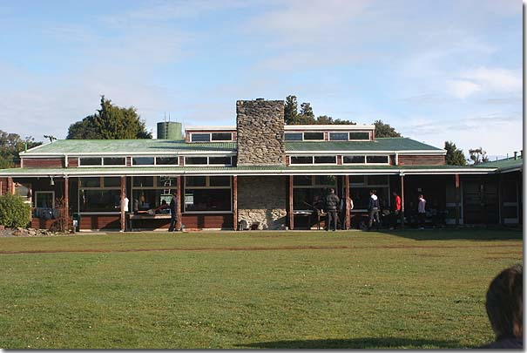
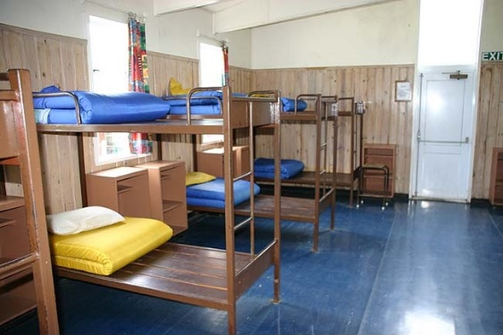
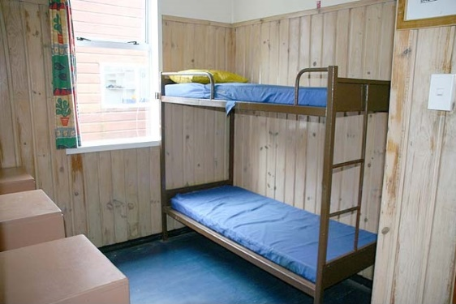

Note that bedding is not supplied, so please bring your own sleeping bag, pillow, etc.
For more information: http://www.youthadventure.org.nz/page.php?id=52

Alternative accommodation in Papatowai

Tautuku Forest Cabins
https://www.forestandbird.org.nz/our-community/lodges/tautuku-forest-cabins
Distance to venue: 2.3km
Rates: $24 per person per night (Forest & Bird member rate)
To book, please contact Roy Johnstone at johns-stones@rivernet.co.nz

Fergus Sutherland accommodation
Capacity: 4 to 6 people
For more details, please contact Fergus at fergussutherland@icloud.com

McLean Falls Holiday Park: http://catlinskiwiholidaypark.com
Distance to venue: 8km via main road
State you are attending the Forest & Bird South Island gathering and get $30 off the advertised daily rate. Book directly at: stay@catlinskiwiholidaypark.com or 03 415 8338

Southern Secret Motel: https://www.southernsecretmotel.co.nz
Distance to venue: 4km via main road
Rates: $120 per night for two people, $18 for extra adult

Hilltop Accommodation Catlins: https://hilltopcatlins.co.nz
Distance to venue: 5km via main road
Rates: from $100 per night for a room, $230-$340 per night for a whole house

Kauriglen Cabin: http://www.catlins.org.nz/accommodationdetails.php?accommodationID=75
Distance to venue: 4.6km via main road
Rates: from $60 per night
Contact details: carolco@yrless.co.nz

For additional options, please contact Carol Geissler at carolco@yrless.co.nz.

Papatowai accommodation on Airbnb

Lancewood Cottage: https://www.airbnb.fr/rooms/15100347?location=Papatowai%2C%20Otago&adults=1&children=0&infants=0

Carol’s Cabin: https://www.airbnb.fr/rooms/19599152?location=Papatowai%2C%20Otago&adults=1&children=0&infants=0

Tram Track Retreat:
https://www.airbnb.fr/rooms/22178411?location=Papatowai%2C%20Otago&adults=1&children=0&infants=0
https://www.airbnb.fr/rooms/22851902?location=Papatowai%2C%20Otago&adults=1&children=0&infants=0
https://www.airbnb.fr/rooms/21400988?location=Papatowai%2C%20Otago&adults=1&children=0&infants=0

