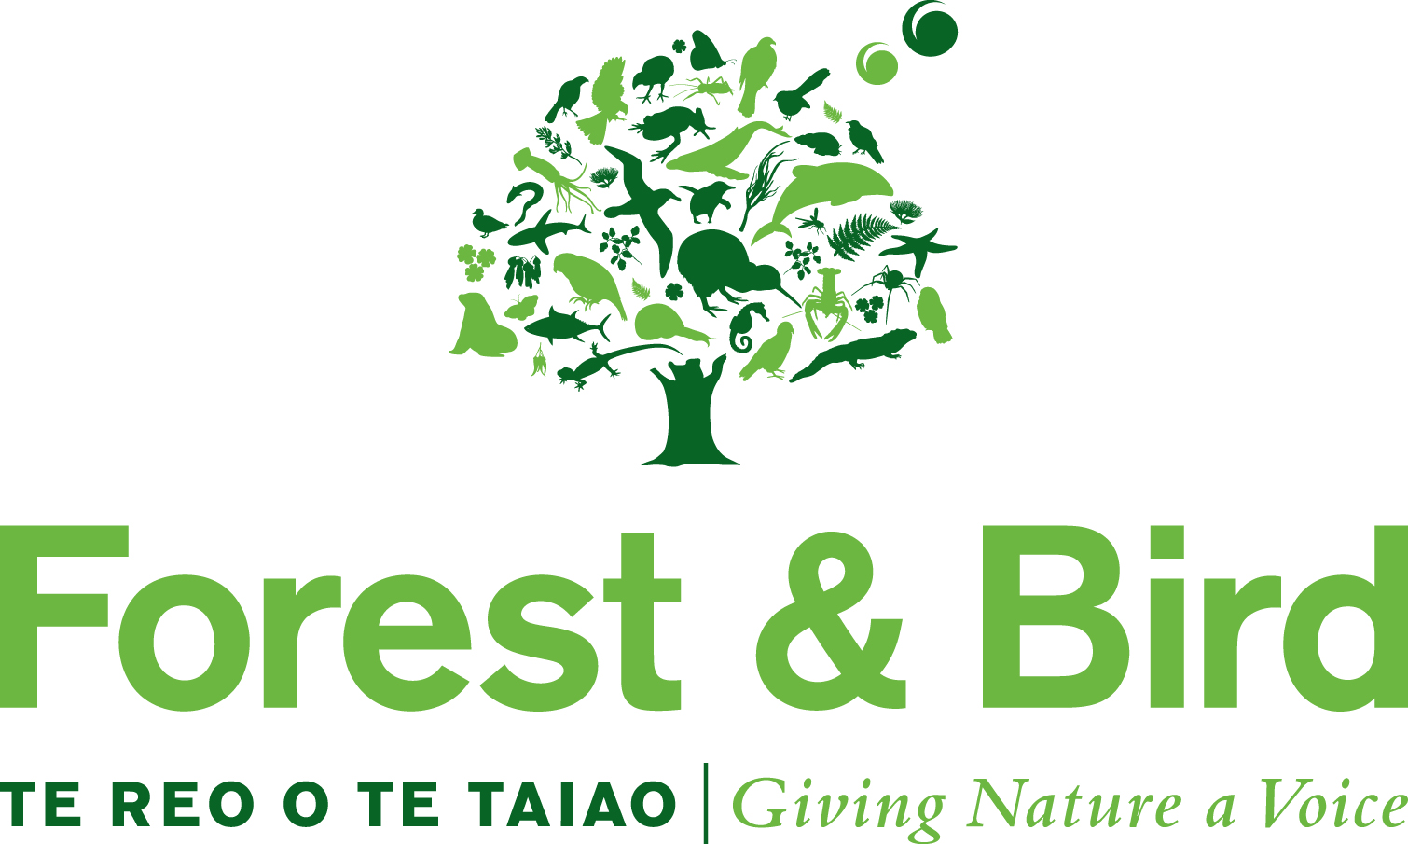

Nomination for Youth Award | Te Kaiārahi Rangatahi o te Taiao Award

Selection Criteria (Please note the nominator may not be a relative of the nominee)
This young person will already have shown all the characteristics of a future conservation leader. It is not necessary that they have already achieved a significant conservation success it is sufficient that they will have:
- Initiated or been integral to the setting up a conservation project.
- Shown perseverance in seeking to ensure that the project keeps going.
- Inspired others to have become involved and actively contribute to the project(s).
- Achieved or be moving toward achieving recognised conservation gains.
They will be:
- A current member of KCC or Forest & Bird.
- Between the ages of 14 and 25
The Award winner will be invited to receive their award at the Society’s AGM / Conference
Sanderson Memorial Dinner – 29 June 2019 in Wellington. Flights and accommodation for the winner and one guardian will be covered by Forest & Bird.

Also,
- incomplete nomination forms will be returned for completion.
- nominations without adequate supporting material will be returned.

Please ensure that all sections of this nomination form have been fully completed.

Nominator Details
Nominator
Relationship to Nominee:
Phone: | Home:  Work: | Cell:
Address
Email

Nominee Details
Nominee name
Guardian’s name
Guardian’s phone | Home:  Work: | Cell:
Guardian’s address
Guardian’s email

Reasons For Supporting this Nomination
Please describe all of the nominee’s personal attributes and activities that show they have met the selection criteria. Where possible provide supporting news clippings, success stories, facts and figures etc.

Please use additional pages if necessary.
Other Information
Has the nominee been informed of this nomination? | Y / N

Referees (people who can be contacted to support the nomination)
Referee Name:
Phone: | Home:  Work: | Cell:
Address:
Email:
Referee Name:
Phone: | Home:  Work: | Cell:
Address:
Email:

Please attach any supporting documentation and forward the nomination form to:

Lorraine Corrigan
Executive Officer
Forest & Bird
PO Box 631
WELLINGTON

Or l.corrigan@forestandbird.org.nz

Closing date for nominations is Thursday 28 February 2019.

OFFICE USE ONLY
Nomination received: | Date: | Initials:
Acknowledgement Sent: | Date: | Initials:

