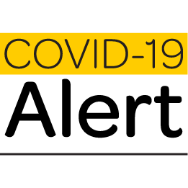
All Forest and Bird Kapiti-Mana Public Meetings have been cancelled until further notice due to COVID-19 restrictions.
If you know other members who may not hear about this, please pass this message on.

This cancellation due to COVID-19 also affects our need to run an Annual General Meeting, so we will be conducting necessary proceedings and voting via mail/email instead.
If you are a member and don’t usually receive our emails but would like to solely for the purpose of participating in the 2020 AGM proceedings and voting, please email KapitiMana.Branch@forestandbird.org.nz by 5 April 2020 to be included.

If you wish to change your general email settings for Forest and Bird, please email or call:
membership@forestandbird.org.nz or 0800 200 064.

Wishing you good health !
Ngā Mihi

