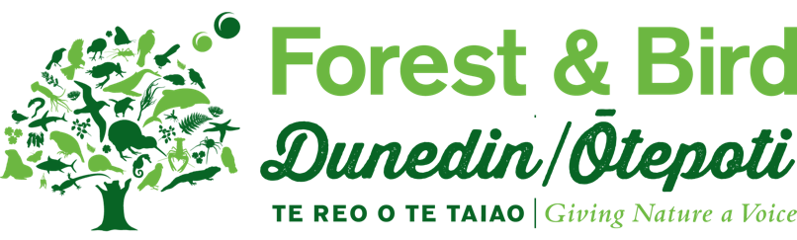

Research Grant — Application Form
Forest & Bird is New Zealand’s leading independent voice for nature. Its members, branches and staff carry out a range of conservation work — from practical conservation projects to influencing national and global decision-making at the highest levels of legislation and public policy.
This research grant is available for conservation projects related to biodiversity outcomes in the Otago region. In total, up to $9,000 NZD is available over a three year period. This may be split amongst several applications. Preference will be given to those projects that align with Forest & Bird’s Strategic Plan. Successful applicants must provide a report within eight months of receiving the funds which may be made public and provided to interested parties.

How to apply
Please complete the following application form and send it with all supporting documents directly to dunedin.branch@forestandbird.org.nz.
Applications are due by 5pm on Friday 19th March. We will notify all applications whether they have been successful as soon as possible.

Section 1: Applicant details
Full name
Address
Phone
Email
Organisation where this research will take place
I confirm this institution is aware this research is taking place.
Date funding was received:
Date report was submitted:
Have you received funding from Forest & Bird before?
Yes No
If you answered yes, please provide
- Date funding was received:
- Date report was received:

Section 2: Project details
Project title

Project start date
Project end date
Project description
150 words or less

Project location(s)

Organisation(s) or institution(s)
Where this research will take place and/or facilities will be used.

Project aims
150 words or less

Project methods
150 words or less

Project outcomes
150 words or less

Please describe the conservation outcomes this project will have within Otago
150 words or less

Please describe how this project aligns with Forest & Bird’s Strategic Plan
150 words or less

Budget
Please include a detailed budget for the amount you are requesting.
Item | Number | Amount (excl GST)
 |  | $
 |  | $
 |  | $
 |  | $
 |  | $
 |  | $
 |  | $
 |  | $
TOTAL |  | $

Supporting documents
Please include the following documents to support your application:
A copy of your CV (no more than 2 pages).
An official letter of support from any organisation(s) or institution(s) where this research will take place and/or where facilities will be used.
A letter of reference from someone who knows you well and is familiar with your project.

Signature
I confirm the information I have included is accurate and true to the best of my knowledge.
Signature | Date

