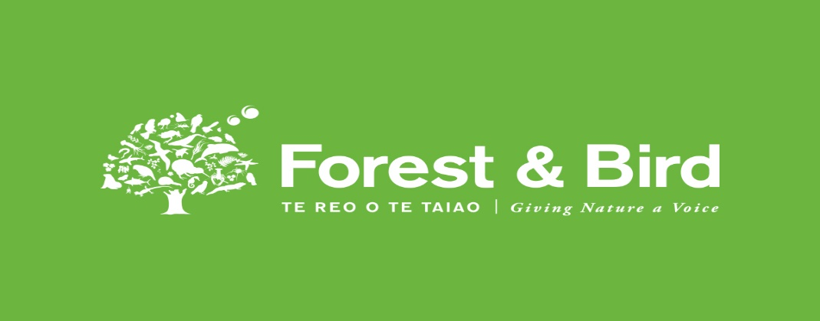
Winter

Newsletter
Rotorua Branch
July 2021

Dear Members

Many activities continue and it is pleasing to see many of our members doing volunteer work for Forest & Bird, attending meetings and participating in field trips.
In this newsletter we have information on upcoming events, a report on the National Conference and several updates. If you are a new member and would like more information, please feel free to contact us by email: rotorua.branch@forestandbird.org.nz

Or keep up to date by visiting our Face Book page, Forest and Bird Rotorua.
Events coming up
AUGUST
03 August (Tuesday) – Speaker Kelvin Hastie. Predator control in an urban environment
Netherlands Society Hall, Neil Hunt Park at 7.30pm.

24 August (Tuesday) – Presentation by Envirohub staff in conjunction with Green Drinks
and RLC. Venue – Rotorua Lakes Council at 5.30pm

SEPTEMBER 04 – 12 Conservation Week

Royal Society Talk
AUGUST 10 (Tuesday) Speaker Shirley Kerr. Exploring fungi from Rotorua/Kaimai Bush
Venue: Scion. Enter through Eastwood café, Long Mile Rd 6 pm

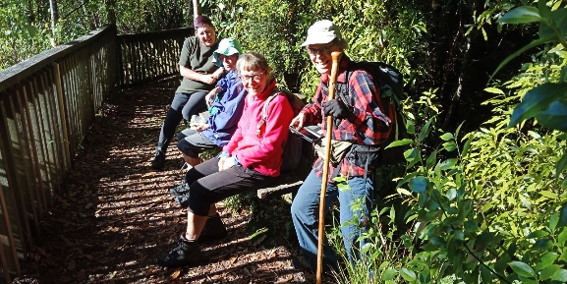
Trip report
Okataina Tracks May 16th
A cloudless sky, no wind and some lovely bush were a recipe for a most enjoyable trip to the bush area by Lake Okataina on May 16th
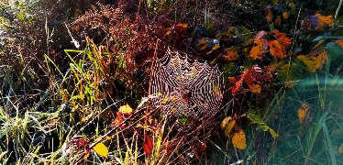
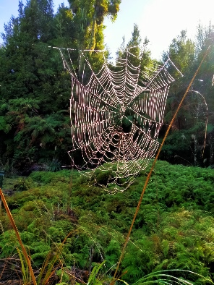
Five people spent several hours meandering through the bush and stopping frequently to examine trees, small plants and abundant fungi. A feature of the morning was the plentiful spider webs – of a variety of types – spangled with dew and sparkling in the sun. The two lovely crater lakes, which are looked down upon from the Ngahopu Track, are a real feature of the area but are not visible from the road. We picked up our walking pace in the late morning and walked via the bush tracks down to Lake Okataina for a leisurely lunch in the sun. The walk back to the car, an initial steep climb from the lake saw us retrace our steps to the junction with the Western Okataina Track; from there it was about half an hour’s walk back to the cars parked near the Outdoor Education Centre.
Margaret Dick
Pop these events on your calendar

Rotorua Branch of Forest and Bird. Events in August 2021

Tuesday 3rd August 7.30pm. Netherlands Society Hall, Neil Hunt Park.
“Wellington Predator Free? How does a city do it? A presentation by Kelvin Hastie on Wellington’s efforts to end cyclical pest control and eradicate predators from the city. He will describe progress to date, partnerships with local government and NGOs and goals for the future. “If we all work together, anything can happen.”

Tuesday 24th August - with Green Drinks and RLC, 5.30pm.
“Improving Coordination of Environmental Projects in the Rotorua Lakes area. A Proposal to establish a permanent base for Envirohub BOP in Rotorua.
A presentation by Envirohub staff about their work and current initiatives. (Envirohub BOP is one of 17 Centres around NZ aimed at helping local communities with environmental Issues.) To date their main presence in Rotorua has been the “Sustainable Backyards programme each March. www.envirohub.org.nz There will also be a presentation by the new, Tauranga based, BOP Coordinator for Predator Free. This meeting will help gauge support for the establishment of a base for Envirohub, with a permanent staff member in Rotorua.
Please note the change of night – Tuesday. The different venue – Rotorua Lakes Council, and the time 5.30pm.

Envirohub BOP Regional Hui 29 May 2021 Te Puke
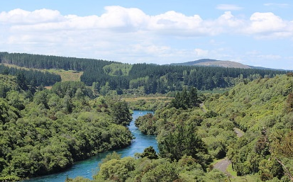
An enthusiastic group of people involved in environmental projects met on a very wet Saturday to hear Rob McGowan (Pa Ropata) speak about “Tiwaiwaka - Healing the mauri of the whenua.” The theme was that we are all part of nature and should work collaboratively to restore it.
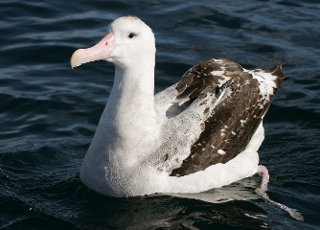
Andrew Crowe (author of the “Which” series eg. “Which Native Tree?”) spoke about his newly published book “Pathway of the Birds.” It is about the skills of the Polynesian navigators who crisscrossed the Pacific, navigating without instruments. He illustrated his talk with examples of the way clouds, wave patterns, fish, debris, bird movements and migrations were interpreted by these skilled seafarers. Joy Moir, based with Envirohub, spoke about their new project - Waiariki Park Region digital platform to help co-ordinate the work of environmental groups in the area from Opokiti to Turangi to Waihi. www.waiarikiparkregion.org.nz

In the afternoon there were sessions on Funding and increasing the Group membership. The Field Trips were cancelled due to the weather. For more about Envirohub and their activities go to www.envirohub.org.nz Heather Sayer

Conservation Week: 4–12 September 2021
Take a moment to celebrate and enjoy nature this Conservation Wek.
Check the DOC website for events https://www.doc.govt.nz/news/events/conservation-week/

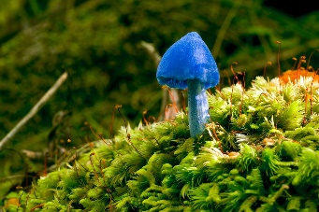
Upcoming Royal Society Talk
Tuesday 10th August, Scion (enter through Eastwood café from Longmile Rd). 6.00pm
Shirley Kerr ‘Exploring fungi from Rotorua/Kaimai bush’
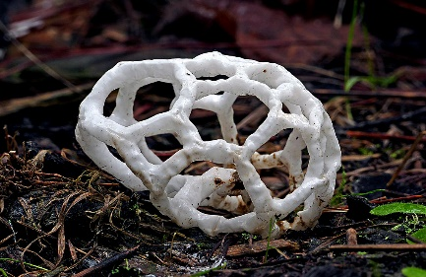
Shirley Kerr has spent many years exploring the Kaimai-Mamaku Forest Park and photographing the “smaller things which often go unnoticed.” Shirley became a Member of the New Zealand Order of Merit in the 2021 Queen’s Birthday Honours - for services to mycology. She has built a database of species on her website Kaimaibush and in 2019 published “A Field Guide to New Zealand Fungi,” which has been highly acclaimed nationally and internationally for its accessibility.
Check out the website - https://www.kaimaibush.co.nz/ - a treasure trove of wonderful photographs.

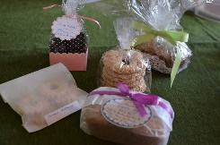
This Photo by Unknown Author is licensed under CC BY-NC
Soft Plastic Recycling
Did you know?

Where: Outside Countdown, 246 Fenton Street, ROTORUA

The following items can now be placed in a recycle bin stationed at Countdown, Fenton St

Soft plastics include: Bread bags Frozen food bags
Courier envelopes Confectionary & biscuit wrap *
Thin plastic bags Toilet & paper towel packaging
Pasta & rice bags Bubble wrap Chip bags *

*Biscuit & chip bags look silver – this is paint, not foil, so can be recycled.
Do not include compostable or degradable bags. Small paper labels can be left on
Items should be clean, dry, and crumpled into a ball to save for recycling.
Soft plastic can be made into ducting, and as a blend with milk bottle plastic for fenceposts.
For more information see www.recycling.kiwi.nz

"The Natural and Built Environment Act which will replace the Resource Management Act, has just been released in draft form. Watch for opportunities to comment and/or make submissions."

Forest & Bird Council Meeting and National AGM June 27, 2021

Forest & Bird Council Meeting
The Council Meeting included staff updates, election of officers (no changes), award presentations and consideration of remits. The one remit was about F&B Youth Group representation on the board – this passed without dissent.
National AGM
Financial statement. F&B is in a good financial position at present – better than anticipated in 2020 when the potential effects of national lockdowns were being considered. Management restructuring and some reduction of staff numbers contributed to this. Supporter income did not drop as much anticipated and other income remained steady.
Climate Change: Forest & Bird’s Strategic Advisor, Geoff Keey, outlined what the opportunities provided by the Climate Change Commission report and talked about what will be needed over the next few months to encourage the Government to adopt nature-based solutions to climate change. His comments covered Carbon storage in native forests; control of browsing animals (we could store 15% of net emissions if we had healthy forests); conversion of marginal land into native forests; cessation of wetland destruction; restoration of wetlands; stop using coal and stop digging it up; e-vehicles so will need more electricity (wind and biofuels). The rate of progress towards carbon neutrality is very slow and the government needs to be pushed. There is a high chance of powerful industry push back.
The government will be consulting on climate change policies in Aug/Sept this year. F&B is developing submissions. If you have any ideas send your thoughts to Geoff Keey now. Margaret Dick
Forest & Bird Virtual Conference 26th June 2021
The title theme of this year’s conference was “Bringing Back Nature.” Kevin Hague, our CEO, suggests that most New Zealanders don’t realise how much we have lost - we get excited now when we see 3-4 kereru, when they were once in flocks of thousands!
In the aftermath of Covid, economic recovery that places Nature first will have huge advantages in slowing Climate Change and adapting to it. It will also work for Nature’s recovery.
The acting Minister of Conservation spoke about the National Biodiversity Strategy which recognises that people are part of nature and that by working with Nature we all benefit. This was reinforced in several sessions drawing on the philosophy and concepts of Mataurangi Maori - the Maori World view expressed in cultural ways but often with a scientific focus. Te Mana o te wai is a principle embedded in the National Freshwater Policy Statement. The other theme that emerged was of Collaboration and Cooperation exemplified by a presentation about a community project in Te Atatu.
Several politicians were involved. Helen Clark gave some of her impressions with a global perspective - “everyone has good reasons for delaying action on Climate Chang but we either pay now or pay later.” Her book “Climate Aotearoa” was published recently. James Shaw outlined some work in progress on an Emissions Reduction Plan, changes to the Emissions Trading Scheme and a National Adaption to Climate Change Plan. David Clark in his role as Minister for Oceans and Fisheries spoke about the many challenges, including bycatch, Marine Reserves and bottom trawling. His talk followed one by Dame Julia Gerrard on her Report on Commercial Fisheries where she stressed that with less fragmented leadership in Government, we have much of the legislation and tool kits we need to make a difference quickly. The final theme is a continuation of that emerging over the last few years:
“Restoring Nature not merely Protecting It.” Heather Sayer

Youth Hub
Over the past couple of months, Forest & Bird Youth Rotorua hasn't been too active, as school has been quite busy and we are still trying to get more people involved.
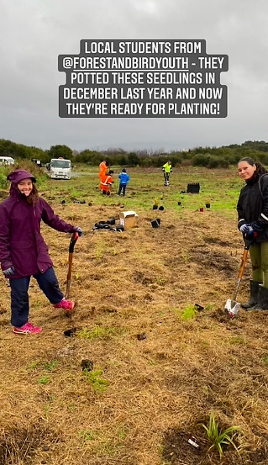
We've been doing our weekly trapping in the Redwoods, where we've recently installed two possum traps, but haven't caught anything yet.
The Forest & Bird youth leaders, Jessica and Kaitlyn, have been involved with the Tikitapu Pest Control. Clearing the tracks, preparing the traps, and enjoying the beautiful bird and plant life in the bush, where we've found AWESOME fungi too!!! Who knew fungi were so fungi-tastic :)
We were also involved in the Sanitorium Reserve planting on the 19th of June. Last year in November, our youth hub potted up some of these native seedlings in preparation for this day. 100 native trees were planted which is incredible!
Fun Fact: In 1969 this used to be the Rotorua dump!!
Now it’s an important breeding sanctuary for endangered native species such as the black-billed gull and prostrate kanuka. I think we all learnt something new there!

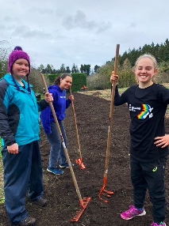
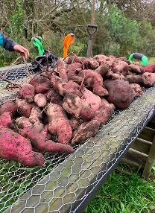
On the 7th of June, some members went to Te Puea Orchard where we learnt how microbes and bacteria play a vital role in soil health. We prepared an area with Kai Rotorua for a regenerative horticultural trial. During this time, we also dug up lots of kumara!!! That was the best part of the day! The kumara there grows massive!! We estimated that our biggest one weighed 1.5kg.

We are now participating in Plastic Free July, where we will be posting some tips on our Facebook and Instagram pages. So, make sure you follow us on taupo.rotorua.forestandbirdyouth to see what we're up to!!! Until next time and thanks for reading! Jessica & Kaitlyn (report & photos)

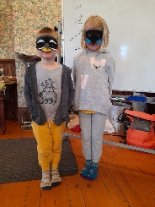
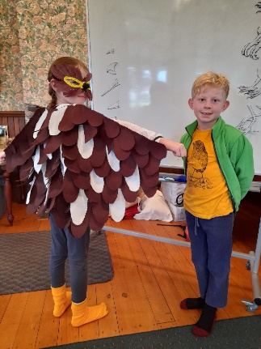
A flock of keen bird enthusiasts, young and old, gathered in Rotorua's beautiful Government Gardens for a mid-winter expedition. They searched for, observed, identified, described, enacted and drew all sorts of aspects of birds and their behaviour.
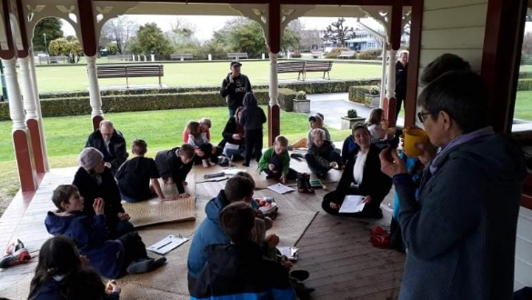
The KCOs were extremely impressed with the knowledge and creativity of all the children who joined them for this lovely afternoon. We look forward to more sharing of adventures, ideas and fun!

Piwakawaka & Kokako masks Karearea and Robin
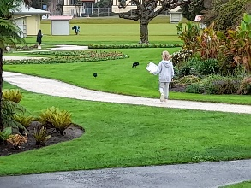
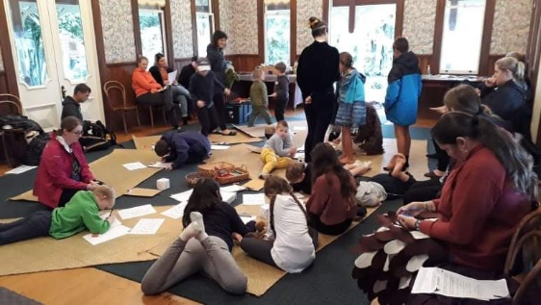

KCC children in the rain 17 children attended and were
looking for birds, even pukeko! involved in all the exciting activities.

Photos Linda & Sky Sky, Judy & Linda

Tikitapu Pest Control 2021

All the bait lines have been checked and cleared in preparation for filling the bait stations in August. This year we will be using Double Tap (containing both Diphacinone and Cholecalciferol) which will target both rats and possums. The normal monitoring of both rodents and marsupials will be carried out both pre and post baiting. Should the post baiting results show unacceptable numbers of possums, Feratox ® (cyanide) will be put out for 2 weeks.
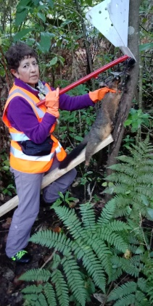
If you would like to participate in the programme, and are not already on the volunteer email list, please contact Frances Blakely:
ph. 362 8480 email jandfblakely@gmail.com

Dates
Double Tap out – Sunday 15th & Monday 16th August
Double Tap top up– Sunday 29th & Monday 30th August
Clear all stations of any remaining bait - Sunday 19th & Monday 20th September
If it is required Feratox will be employed in October

Photo of Val releasing a dead possum from a sentinel trap

INDIGENOUS FORESTRY
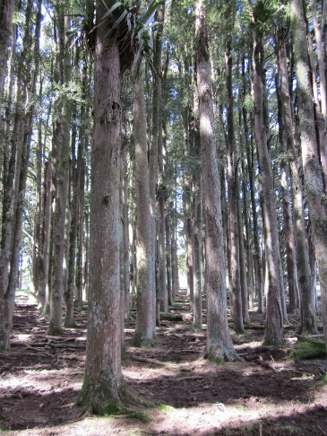
A talk by Greg Steward, SCION, to Rotorua Branch of Forest & Bird,
7th July 2021
An audience of c. 50 enjoyed hearing Greg speak about his work in indigenous forestry over the past 45 years. His work included forest ecology, forest conversion, logging of podocarps, kauri thinning trials, growth modelling, totara growth, yield, harvesting and the establishment of indigenous plantations. He outlined the changes in approach to indigenous forest from huge clearances through to selective logging trials and eventually tree crop trials. Greg illustrated these changes with interesting photos and anecdotes from his own experience. Heather
Photo – Greg Steward taken in 2015

A totara plantation in Northland – planted in 1905

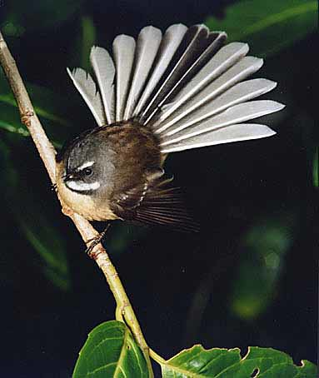
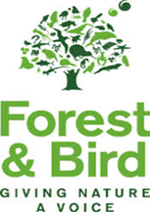
This Photo by Unknown Author is licensed under CC BY-SA-NC
BRANCH CONTACTS

Margaret Dick 3572024
Judy Gardner 3457477
Heather Sayer 3323352
Tania Heasman 3502021
Mike Goodwin 3628865
Jim Rofe 3486636
Did you participate?
The NZ Bird Count 2021
Count at the end of Day 9

Surveys submitted – 5,817
Birds counted – 227,219
Species counted - 130
Linda Johnson 3481669
Sue McGrath 3322121
Te reo o te taiao
Seen a wallaby?
Report to www.stoppests.co.nz

Maori whakatauki
Titiro whakamuri Look back and reflect
Kokiri whakamua So you can move forward

