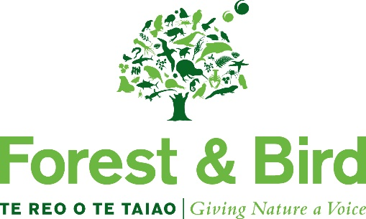

Nomination for Tī Kōuka

- Please complete all sections of the nomination form
- Please provide as much supporting information as possible
- All nominations must be approved by the branch committee and submitted either via the official Forest & Bird branch email or via mail

Award Category:
Level Two Conservation Award – Tī Kōuka Award (as Maori symbol of persistence and longevity)
Criteria

A Tī Kōuka Award may be awarded to a member who has made a significant contribution, over a long period of time, to:
- Advancing the Society’s Strategic Plan objectives locally and regionally

The nature of the work that the nominee has undertaken may include:
- Practical hands-on work
- Fulfilling organisational, administrative or representational roles on behalf of their Branch
- Fulfilling any other role that can be shown to have significantly progressed the Society’s objectives

Nominations for Tī Kōuka awards can be made any time during the year and are subsequently considered by the Board. This award is to be presented by a Board member at a regional meeting, island gathering or local branch meeting.

Nominator details
Nominator name:
Contact name
(if different to above):
Phone: | Home:  Work: | Cell:
Address:
Email:

Nominee Details
Nominee Name:
Phone: | Home:  Work: | Cell:
Address:
Email:

Reasons Supporting Nomination
Please provide as much information as possible – include examples and attach supporting documentation such as newspaper clippings, newsletters, statistics etc

Please use additional pages if necessary.

Other Information
Has the nominee been informed of this nomination?
Is the nominee a member of the Society?

Referees (people who can be contacted to support the nomination)
Referee Name:
Phone: | Home:  Work: | Cell:
Address:
Email:
Referee Name:
Phone: | Home:  Work: | Cell:
Address:
Email:

Before submitting the nomination form, please check that:
- All sections have been completed
- All supporting documentation is attached

Incomplete forms and/or nominations submitted directly and not through the committee will be returned.

Once complete, please send all documentation to:

e.serianni@forestandbird.org.nz

or

Emma Serianni
EA & Board Administrator
Forest & Bird
PO Box 631
Wellington 6140

There is no closing date for nominations.

OFFICE USE ONLY
Nomination received: | Date: | Initials:
Acknowledgement Sent: | Date: | Initials:

